Download and extract the files into a directory of your choice.
1. Open KiCad, go to Schematic Editor and click on Preferences > Manage Symbol Libraries.
Make sure you are on the "Global Libraries" tab. Browse to the bottom of the table, then click on the “+” icon followed by the “folder” icon. Browse to the location of “BuckParts.kicad_sym” and click “OK”

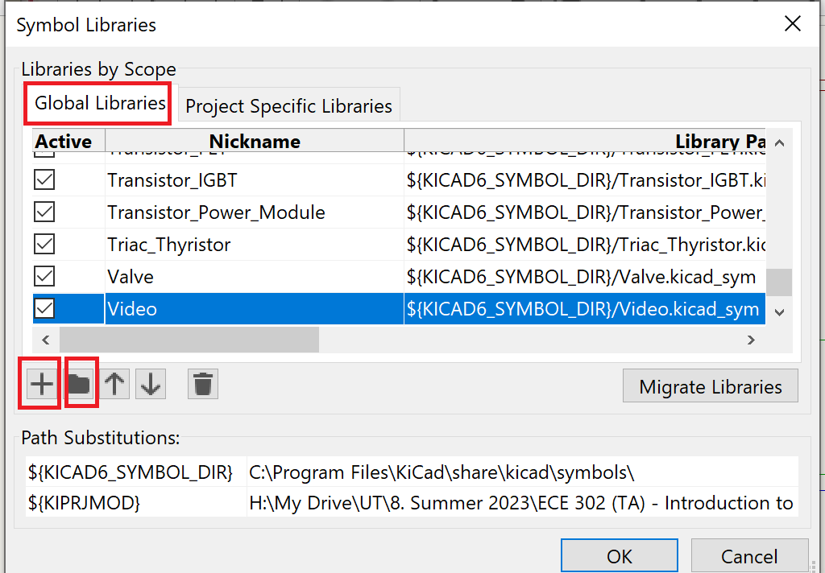
2. Go to PCB Editor and click on Preferences > Manage Footprint Libraries.
Make sure you are on the "Global Libraries" tab. Browse to the bottom of the table, then click on the “+” icon followed by the “folder” icon. Browse to the location of “BuckParts.pretty” and click “OK”
OR
If you would like to use the default KiCad directory, then first navigate to the default location for KiCad symbols (which should be something like C:\Program Files\KiCad\share\kicad)
I. Go into the "symbols" directory and paste "BuckParts.kicad_sym" there
II. Go into "footprints" directory and paste "BuckParts.pretty" there

